SW Concept and Design Description
DTV HAL – CCS2.0

Version: 1.7 16.07.2026

Status: Release

Approval | Date: 16.07.2026 | General Approval Form  [Approval Data / Link]
Distribution list  Recipients: add further stakeholders if needed | Reviewer list  Changes are announced via stages update information, no distribution as printed version,  provision in the Intranet: see footer.
  Name/Department | Role in project
  Meda Srikanth Reddy (MS/ECR1-XC) | Component Architect
  N.N. | Safety Manager (if applicable)
  Nisharani C Paramba (MS/ECR6-XC) | Project Manager
  Name/Department | Role in project |  | Reviewer or approver
  Kavadapu Narasimhulu  (MS/ECR1-XC) | Component Product Owner |  | Approver
  Meda Srikanth Reddy (MS/ECR1-XC) | Component Architect |  | Approver
  N.N. | Safety Team (if applicable) |  | Reviewer
  Cherishnav Reddy Chittamuru (MS/ECR1-XC) | SW-Contributor |  | Reviewer
  Pradeep S  (MS/ERC1-XC) | SW-Contributor | Reviewer
  Nguyen Quoc Dat (MS/EMC32-XC) | SW-Contributor | Reviewer

Contents
1 List of Terms and Abbreviations 3
2 Purpose of this Document 3
3 Introduction to the Subsystem 4
4 Architecture Driving Requirement Groups 4
5 Use Cases 5
5.1 Use case view 5
6 High Level Design 6
6.1 Static Software Architecture and Deployment to Domains 6
6.1.1 Analyzed Alternatives 6
6.2 Provided Interfaces / User Handbook 7
6.3 Dynamic Design on High Level 9
6.3.1 DTV HAL Start-up 9
6.3.2 DTV HAL Shutdown 9
6.3.3 DTV lib System States 9
6.3.4 High Temperature Alert. 10
6.3.5 Suspend to Disk 12
6.3.6 Sync handler – Blocking call 15
6.3.7 Software Update 16
6.3.8 Antenna Monitoring 22
6.3.9 Diagnostic Trouble Code (DTC) Handling 26
6.3.10 Low Voltage Handling 29
6.3.11 DTV Critical Error 32
6.3.12 Death Recipients Handling 33
7 Detailed Design 37
7.1 Static Design on Detail Level 37
7.1.1 Class interaction diagram 37
7.2 Analyzed Alternatives 37
7.3 Mechanisms and Algorithms 37
7.4 Dynamic Design on Detail Level 37
7.5 Concurrency / Threading Model 37
7.6 Data Model View 38
7.6.1 Storage Mechanism 38
7.6.2 Data List 38
7.6.3 Configuration 39
7.7 Critical Computer Resources (CPU, RAM, Flash) 39
7.8 Install View 39
7.9 Security User and Groups 40
8 Testing & Debugging 40
8.1 VTS 41
8.1.1 VTS Test Cases 41
8.1.2 How to run VTS testcases 41
9 Requirements to other Components 42
10 Source Code Reference 42
10.1 DTV HAL 42
10.2 DTV Config 42
11 Open Points 42
12 References and Related Documents 42
13 Contacts 43
14 Amendments 44
14.1 Revision History 44

List of Terms and Abbreviations
Term or Abbreviation | Description
Component Model | In the IEEE standard 1026-1998 the component model is called the decomposition view and in RUP it is called the logical view.
Design Pattern | General approach to solve a common design problem, e.g. observer pattern. A design pattern consists of a problem statement, a solution and consequences (pros and cons).
Dynamic Model | A set of classes that work together to realize a use case, also called collaboration or mechanistic design. In the IEEE standard 1026-1998 the dynamic model is called the dependency description.
IDL | Interface Definition Language
RM | Requirement Management
State Chart | State charts are a formal behavioral language. State charts are particularly effective when the use case is reactive; that is, it has inherent states (conditions) and remains in those conditions until an event of interest has occurred. A state chart is more precise and less likely to be misinterpreted than text, but it is harder to understand. Therefore it should be used together with text and sequence diagrams.
SW | Software
SWAD | Software Architecture Document
Use Case | A use case is a named capability of a structural entity in a model. Use cases organize requirements into chunks. They help to detect open requirements. It is common for a use case to represent and organize many pages of textual requirements or dozens of usage scenarios.

Purpose of this Document
This document is used to record results of architecture and design activities for DTV HAL for CCS2.0.
The document contains both the high level as well as the detailed design. It describes the behavior and how the SW interact with the remaining system. The document shows how the SW part will be arranged to satisfy the requirements and guide the developers for the implementation and maintenance phases. It provides also an understanding, which kinds of requirements are related to which design entities (such like SW components or modules).

Introduction to the Subsystem
DTV HAL is software module which is located in HAL portion of the android software stack in Vendor Partition and
It is configured as a Lazy HAL.
The more details regarding the interaction between DTV HAL and other modules are explained in the later part of this document.

Architecture Driving Requirement Groups
Below are the major requirements full filled in DTV HAL component.
Req No | Scope | Details
R1 | TV Module communication | Provides interface to exchange communication between Host and TV Module
R2 | Firmware update | Provides interface and implementation of TV module firmware update
R3 | TV Module Diagnosis | Diagnosis handling of TV Module related to uart, temp alert, operation, trmp
R4 | TV Module power
R5 | Antenna Diagnosis | Handling of Antenna output power and monitoring

Use Cases

Use case view
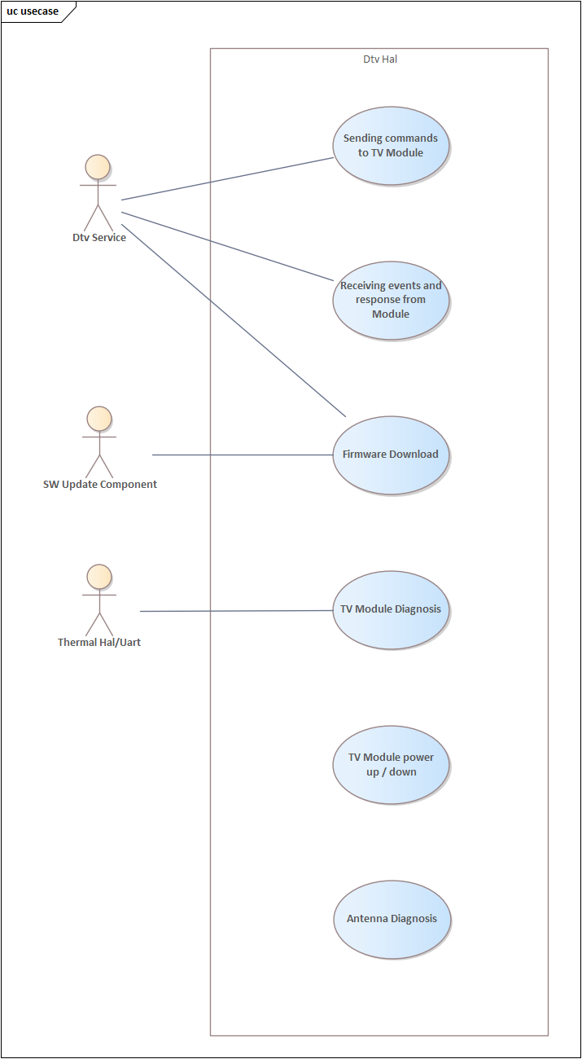

High Level Design

Static Software Architecture and Deployment to Domains
The below image illustrates the interaction of DTV HAL with other modules in the Subsystem.
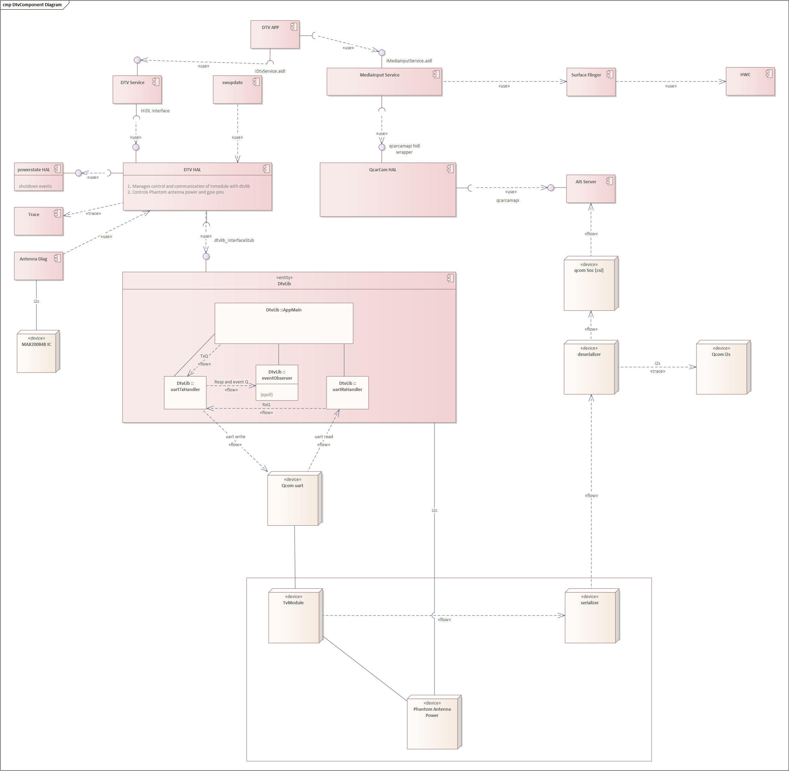
Figure 3

Analyzed Alternatives

This is yet to be updated.

Provided Interfaces / User Handbook
The below are the interfaces offered by DTV HAL.
- Service request interface prototypes are defined in IDTV.hal
  - registerDtvEvents(IDtvEventsCallback callback)
    - Method to register for events from DTV Hal on module health,HAL statemachine and swupdate
    - IDtvEventsCallback callback:- Callback reference to send events from DTV HAL
    - Return Result:- result for the request
  - deregisterDtvEvents(IDtvEventsCallback callback)
    - Method to de-register for events from DTV Hal on module health,HAL statemachine and swupdate
    - IDtvEventsCallback callback:- Callback reference to send events from DTV HAL
    - Return Result:- result for the request
  - registerDtvModuleEvents(IDtvModuleEventsCallback callback)
    - Method to register for events from TV Module
    - IDtvModuleEventsCallback callback:- Callback reference to send events from TV Module
    - Return Result:- result for the request
  - deregisterDtvModuleEvents(IDtvModuleEventsCallback callback)
    - Method to de-register for events from TV Module
    - IDtvModuleEventsCallback callback:- Callback reference to send events from TV Module
    - Return Result:- result for the request
  - sendCommandToModule(DtvCommandDesc command,IDtvModuleResponseCallback callback)
    - Method to send uart commands to TV Module.
    - DtvCommandDesc :- Structure consists of Command ID, IsMultiFragment, CommandType, and Uart data payload
    - IDtvModuleResponseCallback:- Callback reference to send response from TV Module
    - Return requestId :- Unique Id assigned for each request sent by client
    - Return Result :- result for the request
  - performFirmwareUpdate(string firmwarePath)

    - Method to do TV Module firmware update
    - firmwarePath :- folder path where firmware file "thrHigh_AppPkg.tgz" is available
    - Return Result :- result for the request
  - performBlockingFirmwareUpdate (string firmwarePath)

    - Method to do TV Module firmware update. This is a blocking call till update is complete
    - firmwarePath :- folder path where firmware file "thrHigh_AppPkg.tgz" is available
    - Return Result :- result for the request
  - getDtvModuleInfo ()

    - Method to do get TV Module Information
    - Return Result :- result for the request
    - Return DtvModuleInfo :- Module info
  - getDtvAntennaState (DtvAntennaNumber antenna)

    - Method to do get DTV Antenna State
    - DtvAntennaNumber antenna :- Antenna Number for which the state is requested
    - Return Result :- result for the request
    - Return DtvAntennaStatus :- Antenna State

  - getDtvModuleStatus ()

    - Method to do get DTV Module Status
    - Return DtvModuleStatus :- TV Module Status
  - suspend ()

    - Service use this interface to suspend hal operation
    - Return Result :- result for the request
  - resume ()

    - Service use this interface to resume hal operation
    - Return Result :- result for the request
  - getDtvFirmwareVersion ()
    - Method to do get Dtv Firmware Version. This is a blocking call
    - Return Result:- result for the request
    - Return string firmwareVersion : Firmware Version.
- Module Response interface prototypes are defined in IDtvModuleResponseCallback.hal
  - onDtvModuleResponse(DtvCommandRespDesc response)
    - Method called by HAL on receiving response from TV Module
    - DtvCommandRespDesc response : Response form TV Module
- Module Events interface prototypes are defined in IDtvModuleEventsCallback.hal
  - onDtvModuleEvent(DtvEventRespDesc eventDesc)
    - Method called by HAL on receiving event from TV Module
    - DtvEventRespDesc eventDesc : event info from module
- Status interface prototypes are defined in IDtvEventsCallback.hal
  - onDtvModuleStatus(DtvModuleStatus status)
    - Provides status update on current TV Module State
  - onDtvSwUpdateStatus(DtvSoftwareUpdateStatus status)
    - Provides status update on current TV Module firmware update status
  - onDtvAntennaStatus (vec<DtvAntennaStatus> status)
    - Provides antenna status of TV module

- Status interface prototypes are defined in IDtvModuleInfoResponseCallback.hal
  - onDtvModuleInfoResponse(DtvModuleInfo info)
    - Method called by HAL to update TV Module version, partnumber and antennaConfig
    - DtvModuleInfo info: bootVersion, hardwareVersion, firmwareVersion, boschPartNumber, antennaConfig

Dynamic Design on High Level
This section describes the dynamic interactions between components or subsystems.

DTV HAL Start-up

DTV HAL Shutdown

DTV lib System States
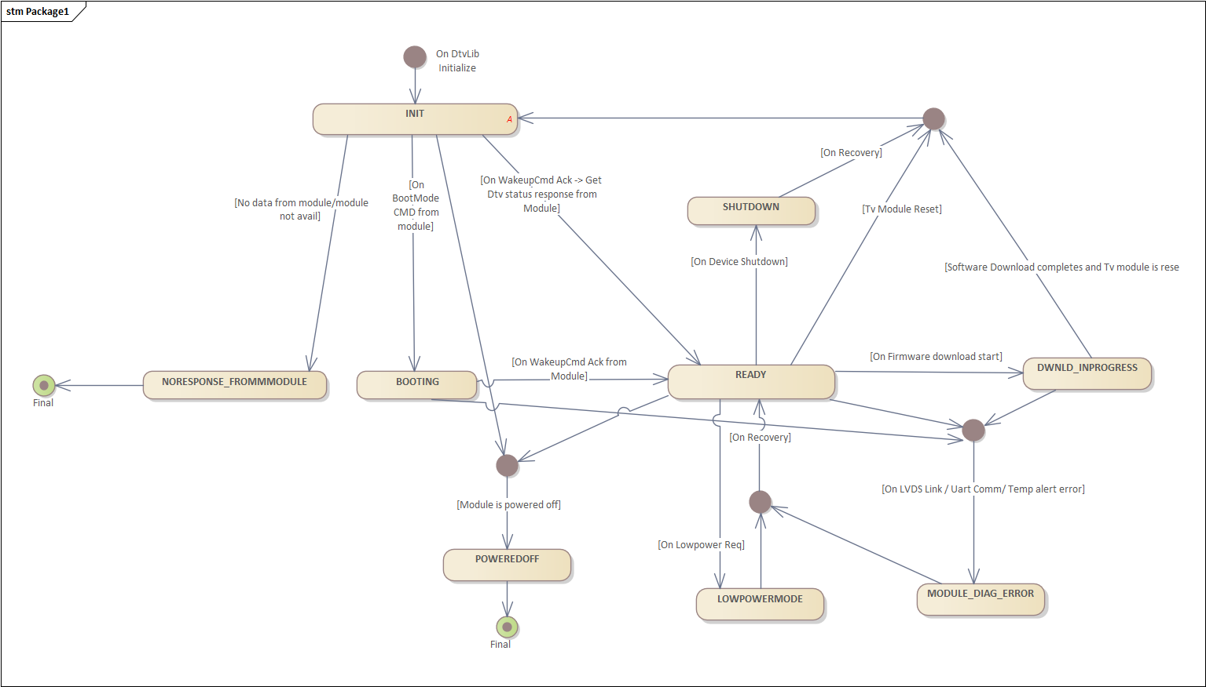

High Temperature Alert.

Monitoring
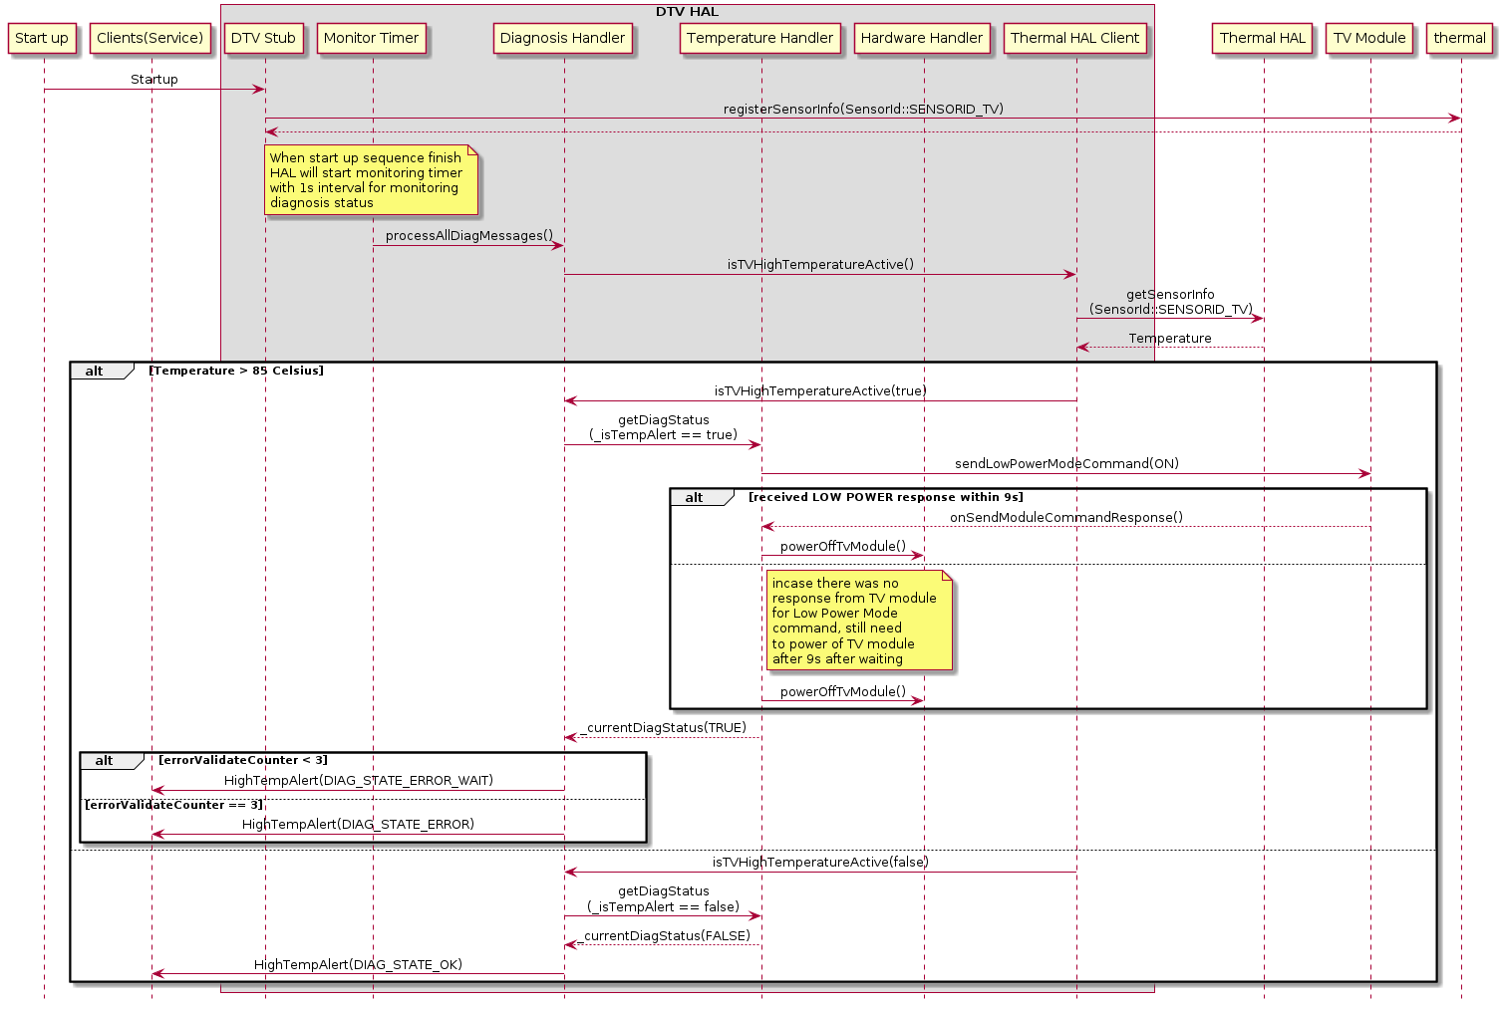

Recover after error
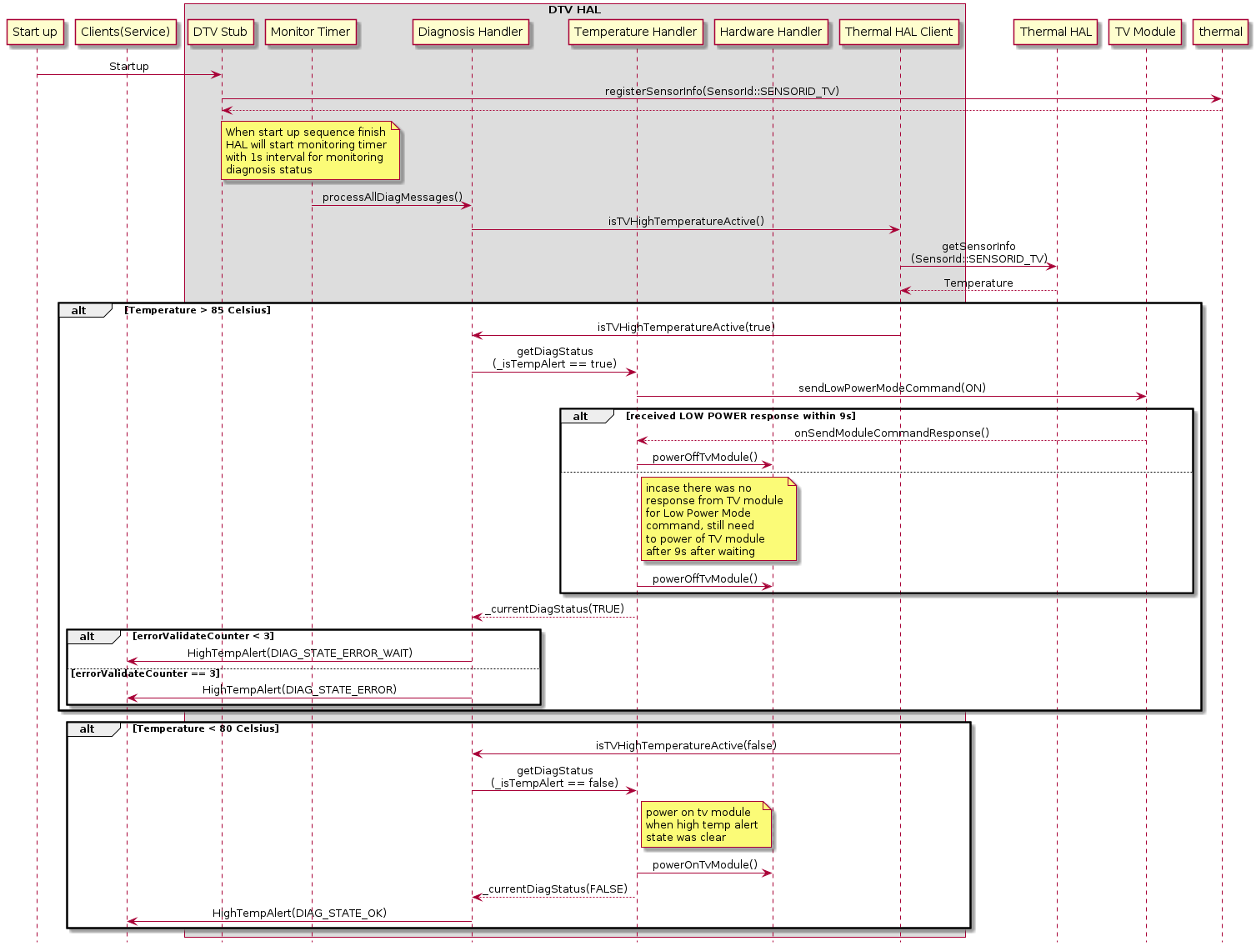

Suspend to Disk

As a requirement for Suspend to Disk, DTV Hal would be notified to resume/suspend activity from DTV Service, based on updated from android.car.hardware.power.CarPowerManager
DTV Hal supports two operations:
Suspend: On receiving this request, DTV Hal would
- Stop TV Module
- Stop UART communication.
- Power off DTV Antenna
- Destroy all instances of instantiated libraries and cleanup resources.
Resume: On receiving this request, DTV Hal would
- Configure and power on DTV Antenna
- Instantiate required libraries and setup communication.
- Start TV Module
Refer to the CarPowerManager state machine below for details.
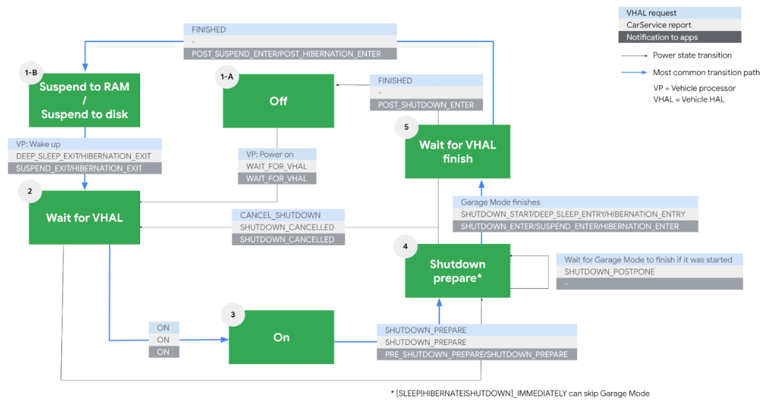
Currently, the DTV service and DTV HAL monitor four events from the CarPowerManager to manage suspend or resume operation.
SHUTDOWN_ENTER/SUSPEND_ENTER: The suspend operation is triggered
SUSPEND_EXIT: The resume operation is triggered
SHUTDOWN_CANCELLED: The resume operation is triggered when SHUTDOWN_CANCELLED is received from CarPowerManager while the system is in WAIT_FOR_FINISH (after SHUTDOWN_ENTER or SUSPEND_ENTER).
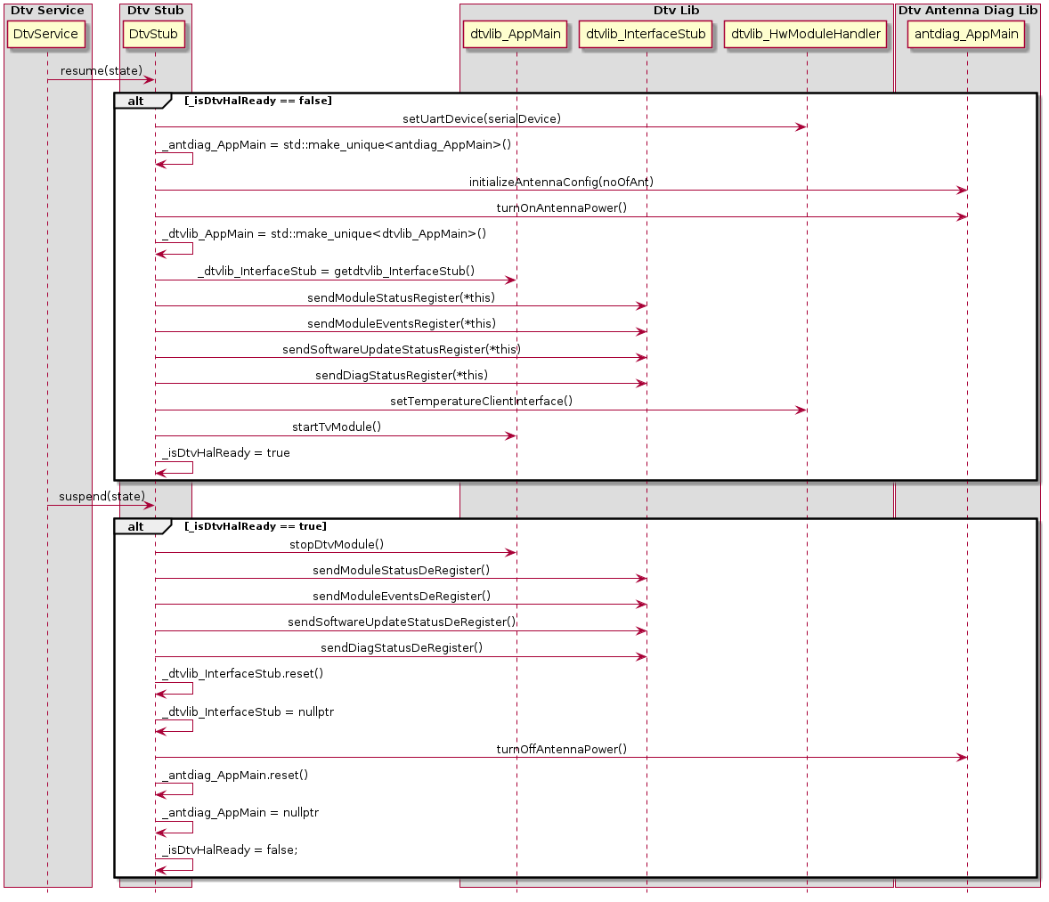

Sync handler – Blocking call
DTV HAL provides synchronous blocking call support for required interfaces.
This handler will take a request from the caller, process it, and returns the response to the caller as a blocking call.
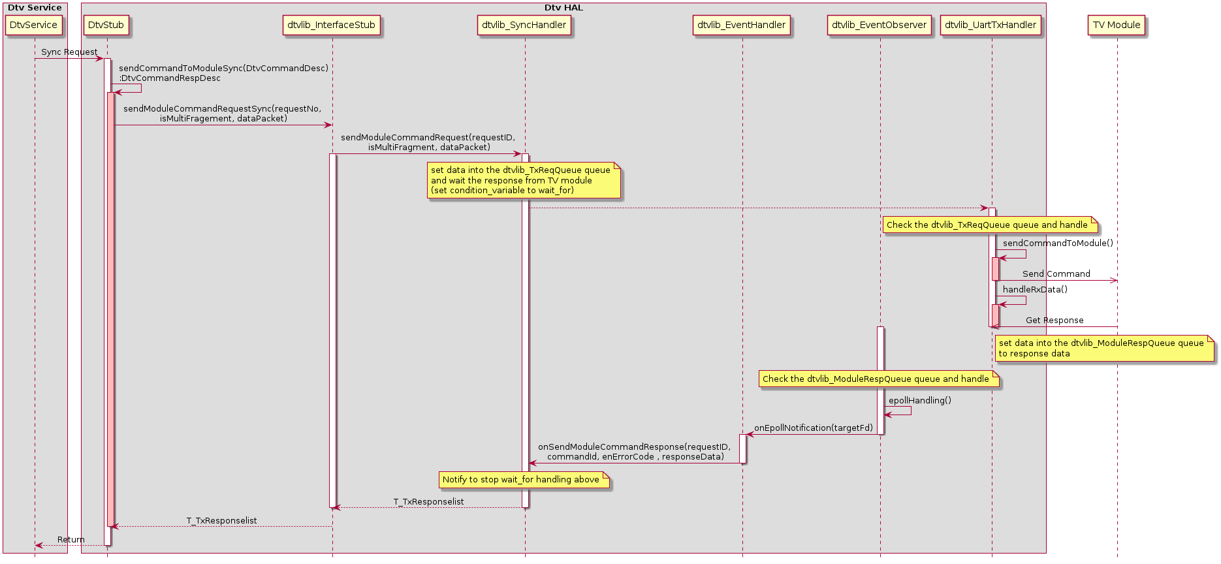

Software Update
DTV HAL supports two operations for the Software update feature. The Software update will operate in either background or the foreground, depending on its current version (refer to the SW Update Mode Identification figure in Software Update Validation session).
It also provides synchronous blocking call/ asynchronous call support for required interfaces.

Software Update Validation
This process will validate the availability of the firmware update operation.
Based on the data in version.txt file and the current firmware TV module. The DTV HAL will then determine which operation can be initiated.
Currently, DTV HAL supports four operations:
- Upgrade Operation
- Downgrade Operation
- Not perform firmware update operation but DTV HAL will return success as requirement from Software Update component.
- No support (It can occur if there is missing data in version.txt file)
Format data of version.txt
Version: TH010XXX
minBgVersion: TH010XXX
minDgVersion: TH010XXX
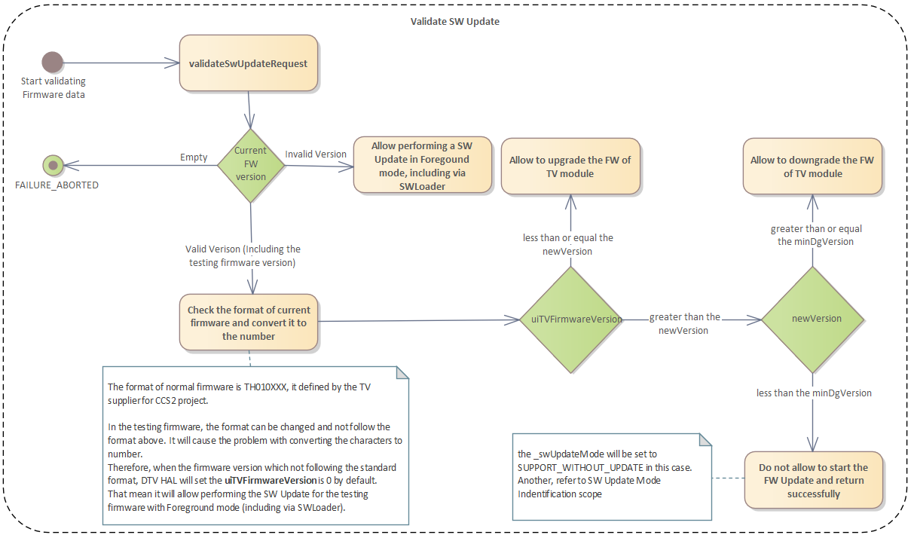
Note: The current TV firmware can either be a valid or invalid (RPDTRMPS) version. An invalid version can occur if the Software Update operation is interrupted after the SW Loader has been completely downloaded.
RPDTRMPS is the SW Loader version, and it can be downloaded to the TV module to initialize the configuration of NVRAM configuration in TV module. This process is necessary when upgrading the TV firmware from a version older than V1.2 (TH010518)
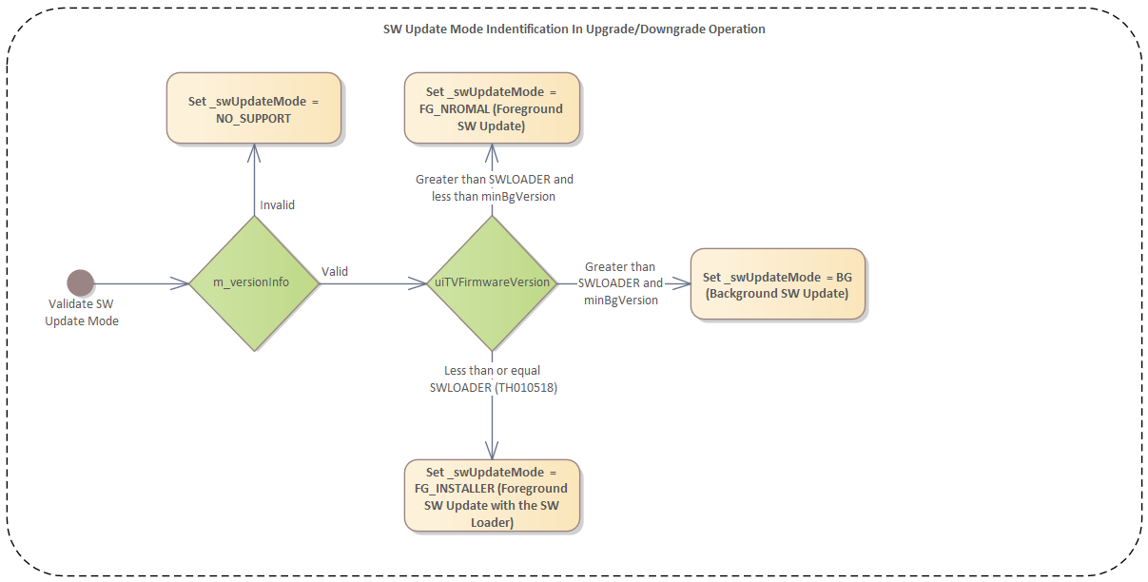

Synchronous blocking call
The software update’s synchronous blocking call is invoked when the user initiates it from the USB Update via the SW Update Service.
This handler will take a request from the caller, process it, and returns the response to the caller as a blocking call.
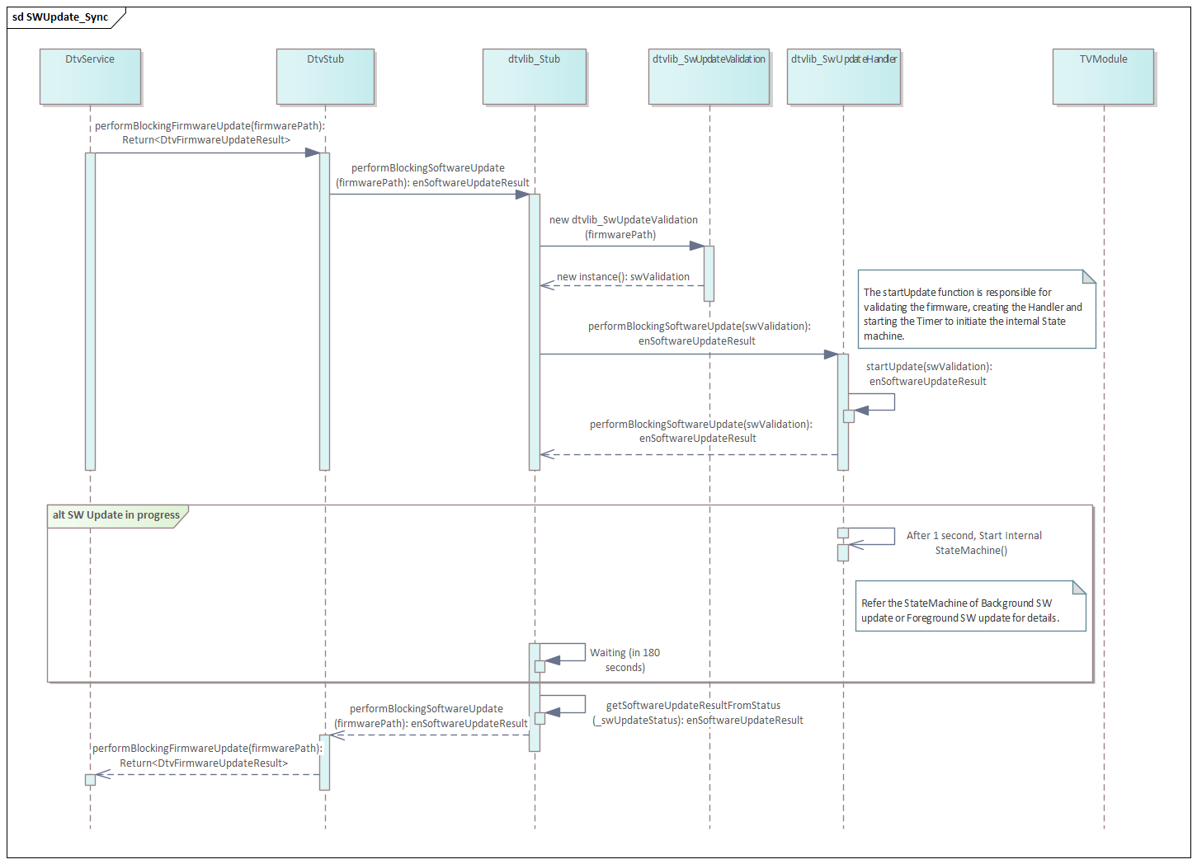

Asynchronous call
The software update’s asynchronous call is invoked when the user initiates it from the Test Mode via the DTV Service.
This handler will take a request from the caller, process it, and returns the response immediately to the caller while the SW Update is in progress.
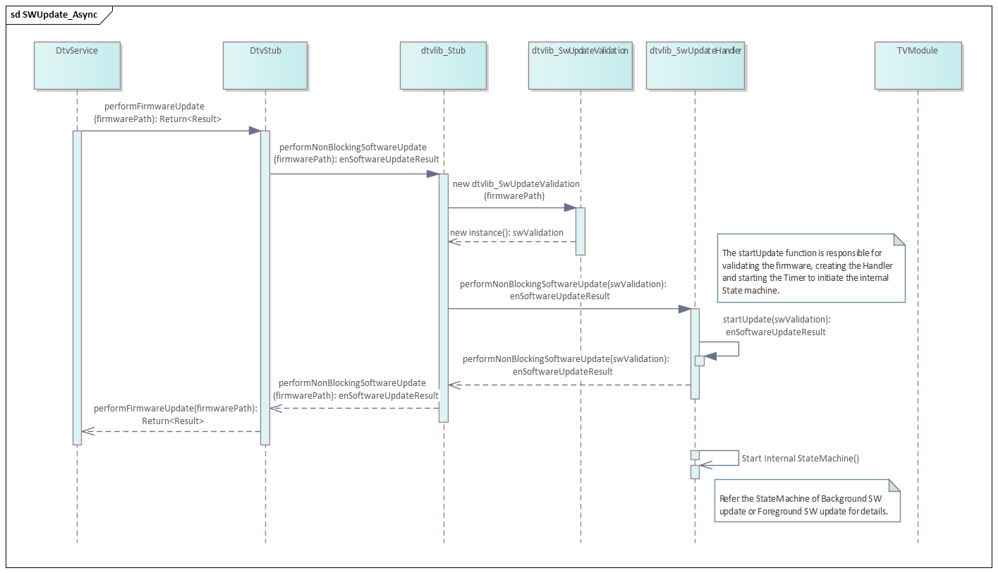

Background Software Update
The SW Update transfer update files via UART command (V2.1 or newer).
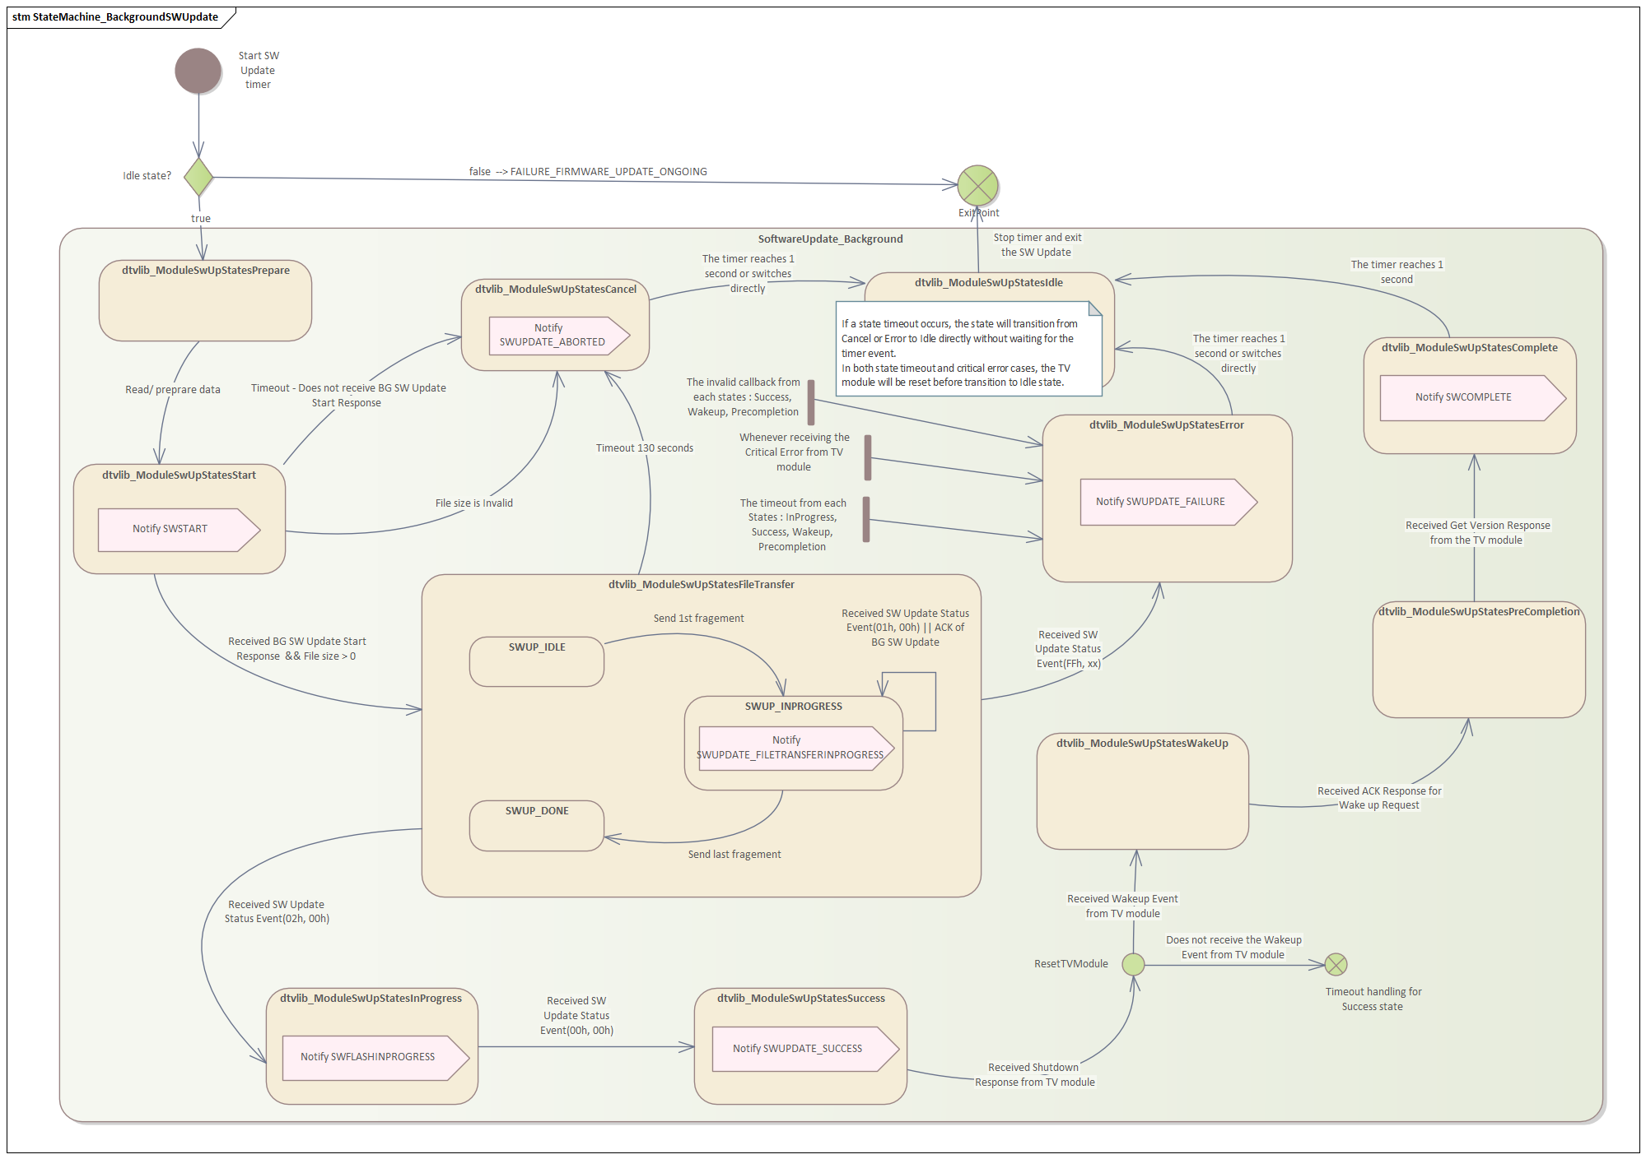

Foreground Software Update
The SW Update transfer update files with YMODEM Protocol.
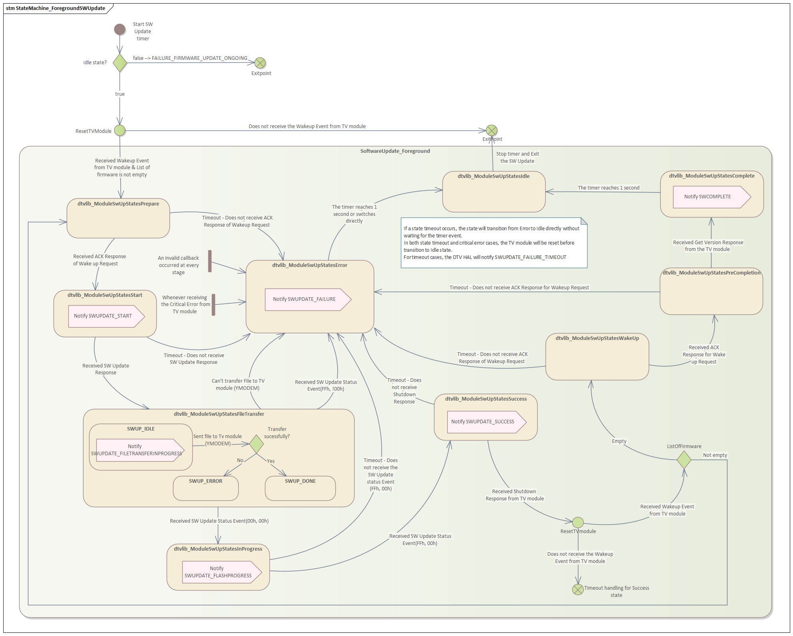

Interrupt Software Update
The software update can be interrupted by certain operations, such as suspending to disk or powering off, among others.
Please note that if an interrupt occurs after the firmware files have been transferred to the TV module, the firmware version will be updated.
In the event that the software update is interrupted, the DTV HAL will revert to an idle state. After resuming, the system will be in a state that allows the software update to proceed.
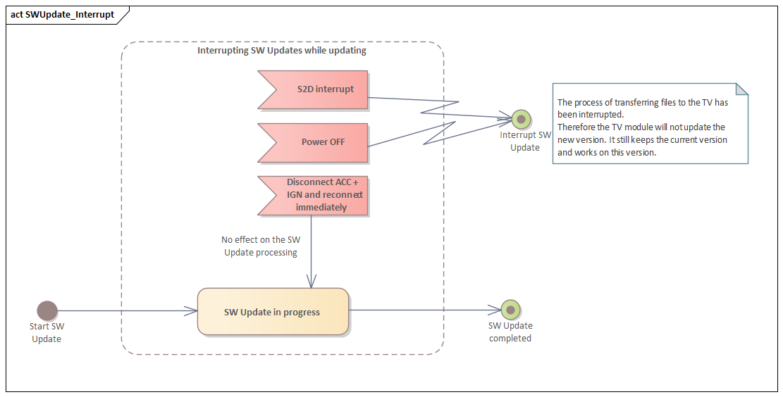

Antenna Monitoring
Antenna is powered using the MAX20084B IC which is mounted on the Sub PCB of silver box.
The MAX20084B is a dual-antenna power supply with an I2C interface for diagnostics and control. The dual 270mA antenna supplies are linear regulators whose output voltage is set individually through I2C interface of IC. Additionally, MAX20084B IC has internal registers which are used to set the current limit, open-load threshold, and other parameters.

For 2-Antenna variants, 1 MAX20084B IC is used, whereas for 4-Antenna variants, 2 MAX20084B IC’s are used.
Antenna Diagnosis communciates with MAX20084B IC through I2C. The registers are read and written using I2C communication.
Antenna Diagnosis supports 3 functionalities:
- Initialize Configuration Registers of MAX20084B IC
- Power ON/OFF the Antenna
- Periodic Antenna Monitoring

Antenna is powered ON explicitly as part of DTV HAL startup sequence when the TV Module is powered ON.
Once Antenna is powered ON, the Periodic Diagnosis monitoring starts and continues at every 320 milli seconds interval. The EN pin of the IC connected to the same circuit as that of TV module power on. Therefore, EN pin is not controlled by the DTV HAL software separately and is powered on simultaneously when the TV module is powered on. Hence before DTV Hal tries to access MAX20084B IC through I2C, the TV module should be powered on.
During Periodic Antenna Monitoring, if Power On Reset(POR) Flag of Diag Register in MAX20084B is set, we initialize all the Configuration Registers of MAX20084B and enable the Antenna Output.
Project Specific Configuration Values :
- Illumination value = 270mA
- Over Current Threshold = 40mA
- Open Load Threshold = 2mA
- Output Voltage = 8V
- Warning temperature = 95 deg C
- Blanking Time = 50ms
- Mask Value is set in a way that reverse current, over current, short to battery interrupts are enabled.
- Over Current Wait Time = 15s

Antenna States
Antenna State – OPEN :
- When Antenna current is less than Open Load Threshold for 3 consecutive cycles of measurement, the Antenna is set to OPEN state.
Antenna State – OK :
- When Antenna current is between Open Load Threshold and Over Current Threshold for 3 consecutive cycles of measurement, the Antenna is set to OK state.
Antenna State – SHORT :
- When the current in a channel reaches the set current limit, MAX20084B limits the output current of the LDO/switch while the output remains ON until the blanking time elapses. If the channel current is above the overcurrent setting in the OC_OL register at the end of the blanking time the channel is disabled and an overcurrent (OC_) fault is declared by the MAX20084B IC.
- When any of the Antenna enters into Short Circuit Error condition (through Over Current Flag, Short to Battery Flag or TShutDown Flag of Diag Registers of MAX20084B), that particular antenna will be powered OFF through MAX20084B IC by disabling the output voltage.DTV HAL waits for a predefined time of 15 seconds before powering ON the antenna again. During this time, Antenna monitoring will be stopped. After the timeout, DTV HAL powers ON the Antenna again and starts monitoring.

Diagnosis requirement is to notify the Antenna State update every 1 second. To ensure consistency of current reading, 3 cycles of current measurement is done in this 1 second interval. Hence Monitor Timer is approx 320 milli seconds (interval) and number of Monitor cycles equals 3.

Activity Diagram
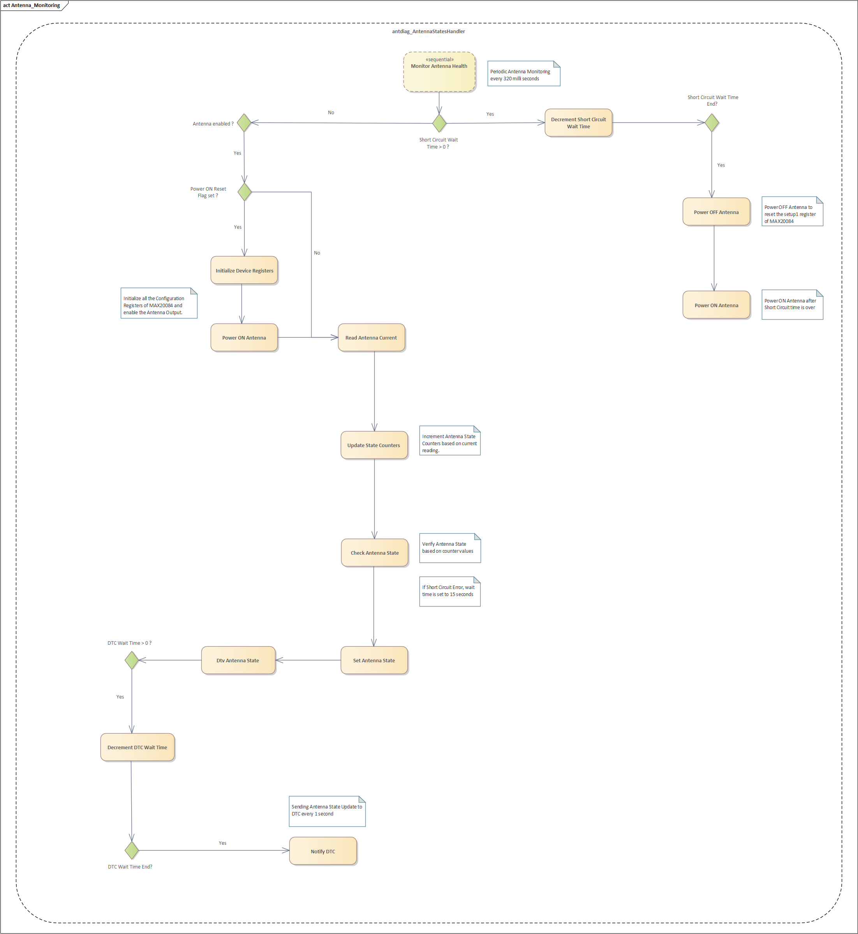

- Antenna Current is read every 320 milli seconds (interval) for 3 monitor cycles.
- The counters are updated based on the current value. If any of the counter value (open, close, short) is same for the 3 consecutive cycles of measurement, the Antenna State is set accordingly and the counters are reset.
- If Short circuit condition is detected, the MAX20084B IC powers OFF the Antenna by disabling the output voltage, and the wait time counter in DTV HAL is set to 15 seconds. Once the short circuit wait time is over, the Antenna is powered back ON by the state machine.
- Antenna State Update is send to DTC every 1 second.

Diagnostic Trouble Code (DTC) Handling
DTV HAL supports sending the DTC to the Diagnosis service vendor.alliance.hardware.automotive.diagnosis@2.0 whenever an error occurs in DTV.
The DTC code and fault type are defined from the diagnosis service ^{[4]} as below:
DTC code | Value | Fault type | Value | DTC Status
DTC_DTV_ANTENNA1 | 0x938C | FT_SHORT_TO_GROUND | 0x11 | PASS/ FAIL
DTC_DTV_ANTENNA1 | 0x938C | FT_OPEN_LOAD | 0x13 | PASS/ FAIL
DTC_DTV_ANTENNA2 | 0x938D | FT_SHORT_TO_GROUND | 0x11 | PASS/ FAIL
DTC_DTV_ANTENNA2 | 0x938D | FT_OPEN_LOAD | 0x13 | PASS/ FAIL
DTC_DTV_ANTENNA3 | 0x938E | FT_SHORT_TO_GROUND | 0x11 | PASS/ FAIL
DTC_DTV_ANTENNA3 | 0x938E | FT_OPEN_LOAD | 0x13 | PASS/ FAIL
DTC_DTV_ANTENNA4 | 0x938F | FT_SHORT_TO_GROUND | 0x11 | PASS/ FAIL
DTC_DTV_ANTENNA4 | 0x938F | FT_OPEN_LOAD | 0x13 | PASS/ FAIL

Sequence diagram
Connect and updateDTC sequence:
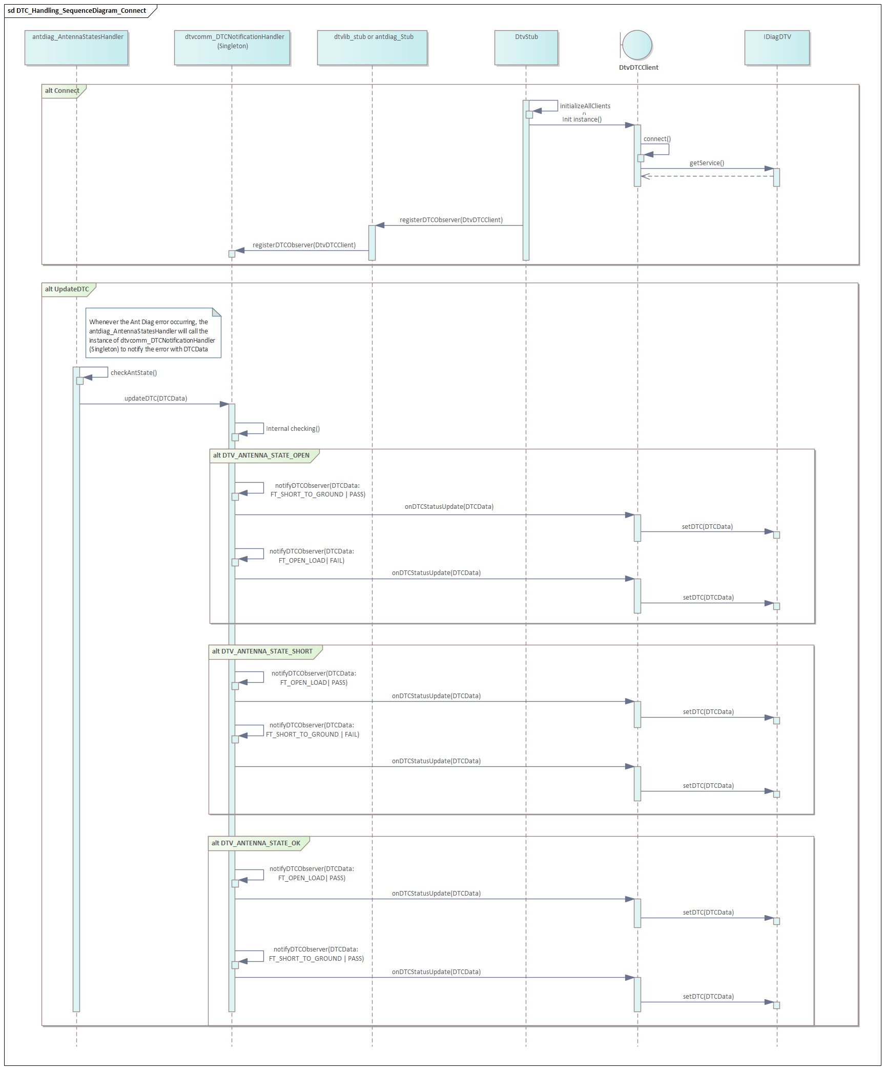

Disconnect sequence:
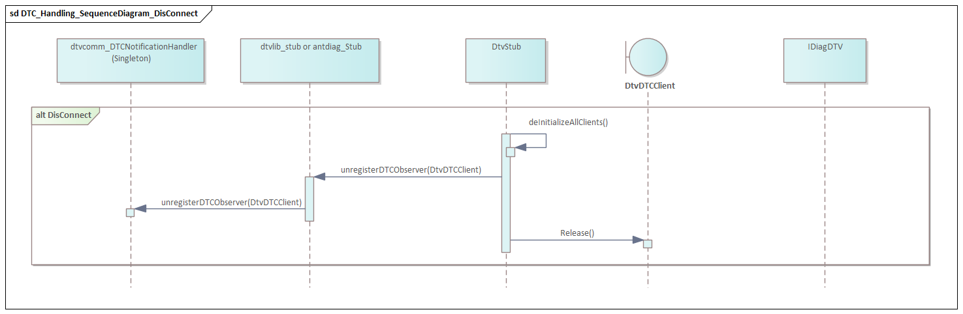

Class diagram
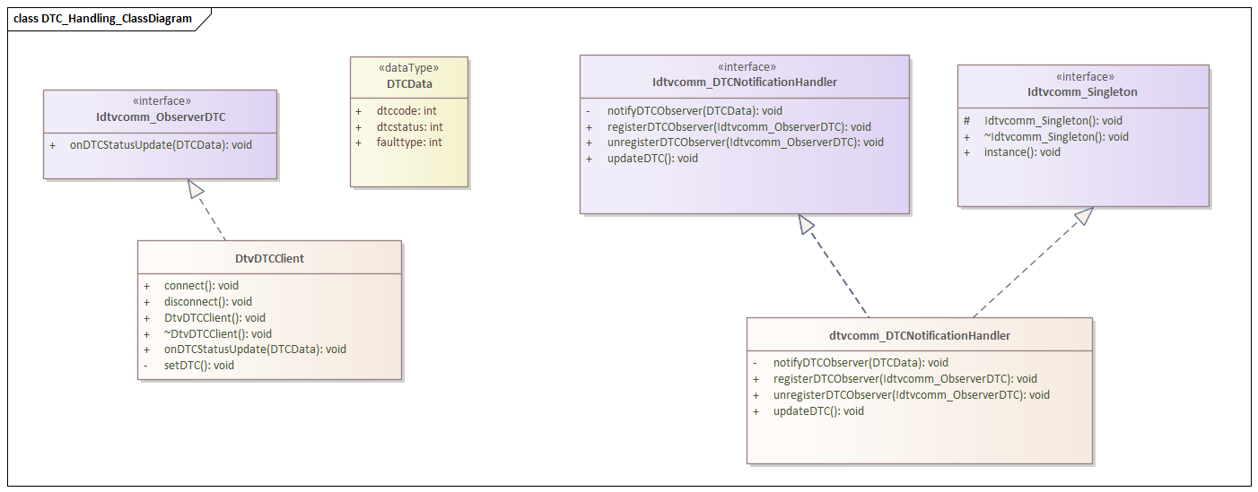

Low Voltage Handling
HW team recommends that, when system is in Low Voltage conditions, TV antenna output voltage should be turned OFF and when System re-enters normal voltage conditions, we should turn ON the Antenna output voltage again.
This is to ensure the power consumption is kept under check under low voltage conditions.
DTV HAL subscribes to Interface IVhalExtensionVolt and registers for notifications on change in System Voltage.
When IVhalExtensionVolt notifies DTV HAL about Low Voltage (VOLTAGE_MGMT_CRITICAL_LOW ~ 6.2V), Antenna and TV module are powered OFF and when system re-enters into Normal Mode (VOLTAGE_MGMT_LOW ~ 6.7V), Antenna and TV module are powered ON again.
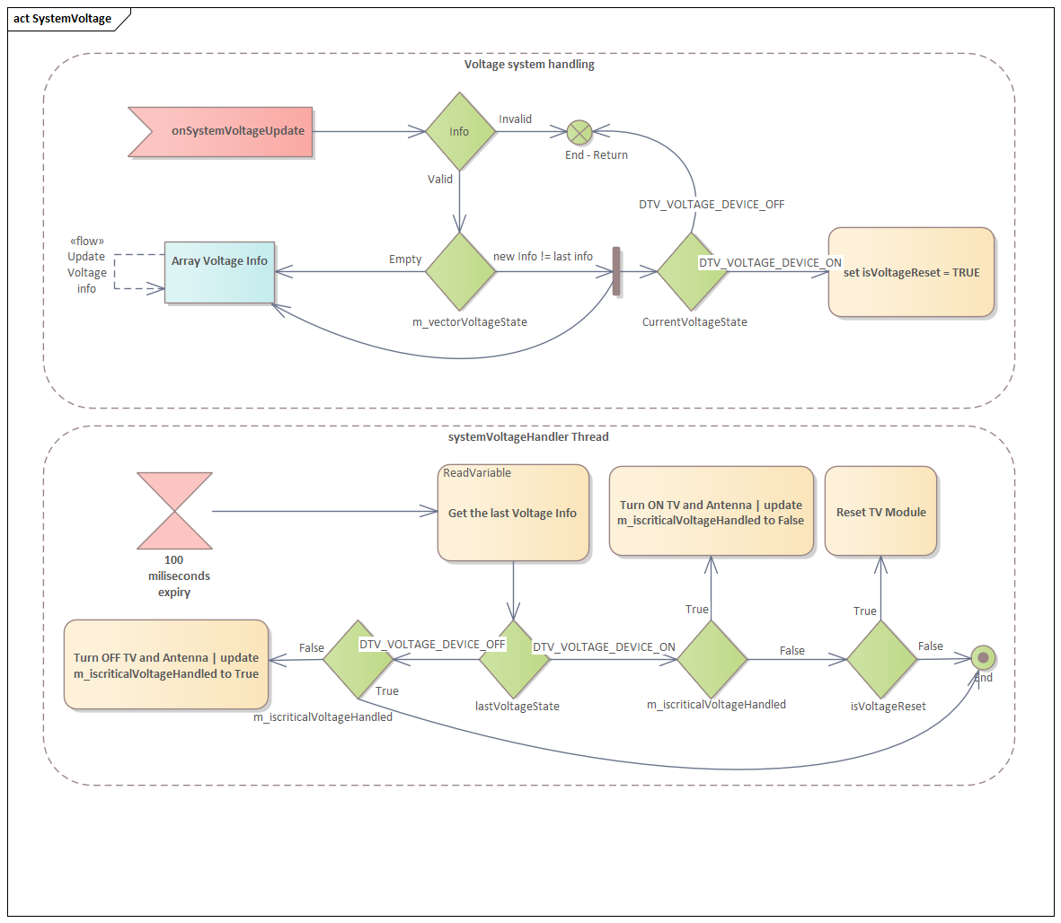

Sequence diagram
Register and Antenna Power Handling sequence:

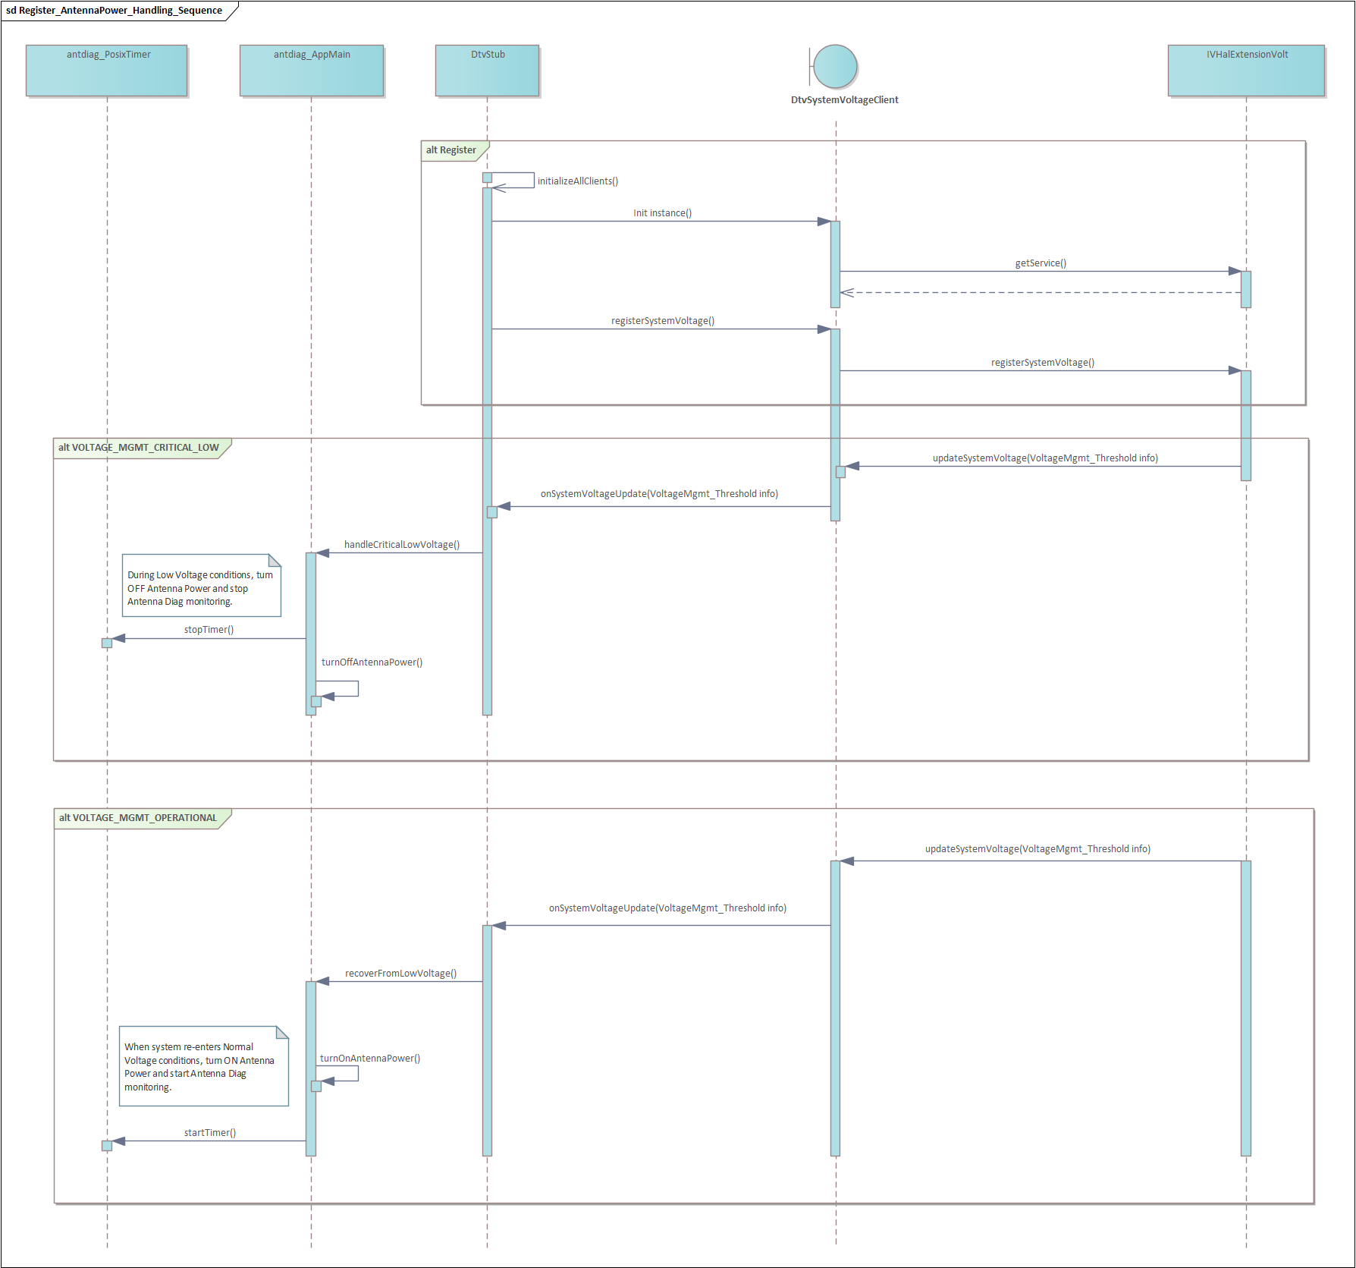

Un-Register sequence:

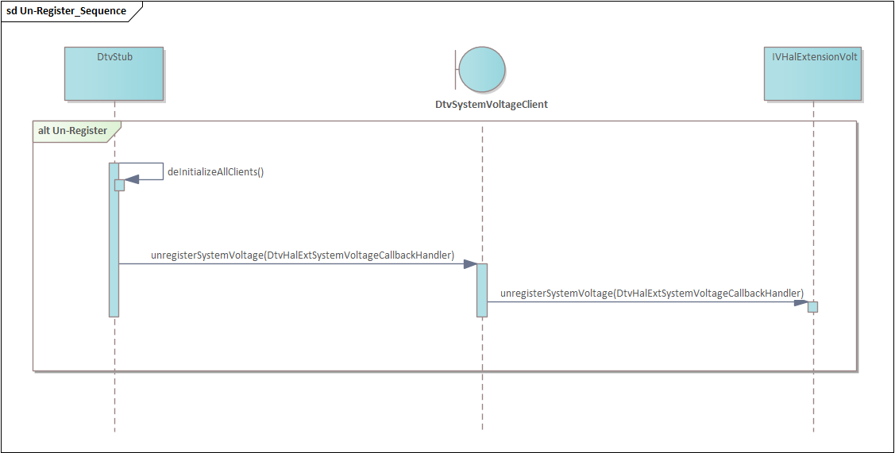

DTV Critical Error
The DTV HAL supports restarting or resetting the TV module whenever critical errors occur from the TV module sides. It also stored the logs in the persistent memory for tracing.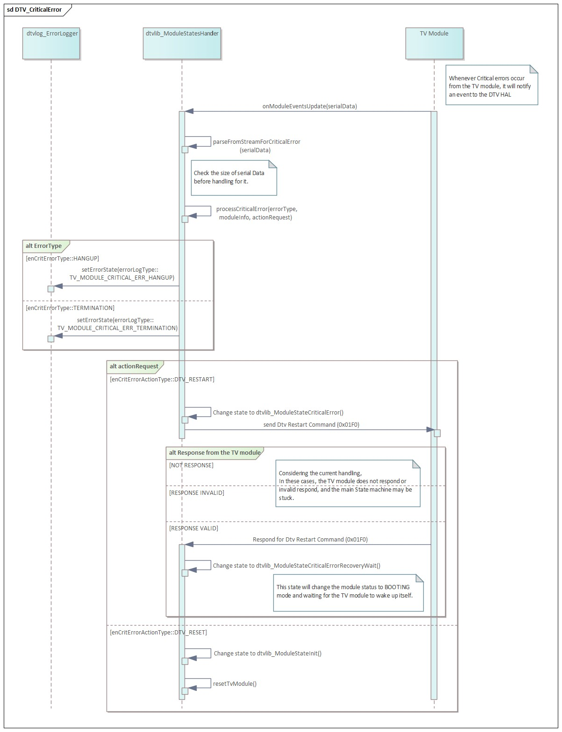

Death Recipients Handling
This section contains details of the way the death recipients were handled for DTV clients like DTC, System Voltage and Temperature handling.
This mechanism ensures robustness and resilience. It allows the clients to detect and recover from service failures, maintaining functionality without requiring manual intervention.

Death Recipient Handling for DTC client:
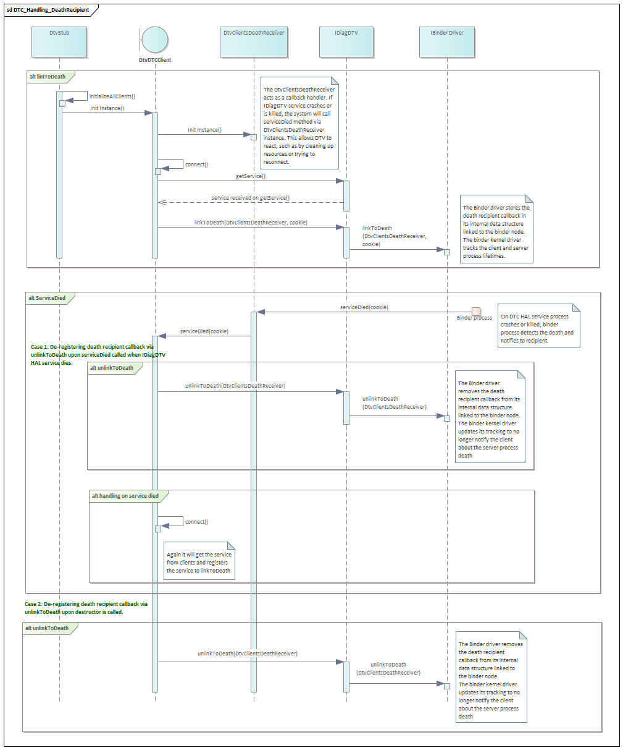

Death Recipient Handling for System Voltage client:
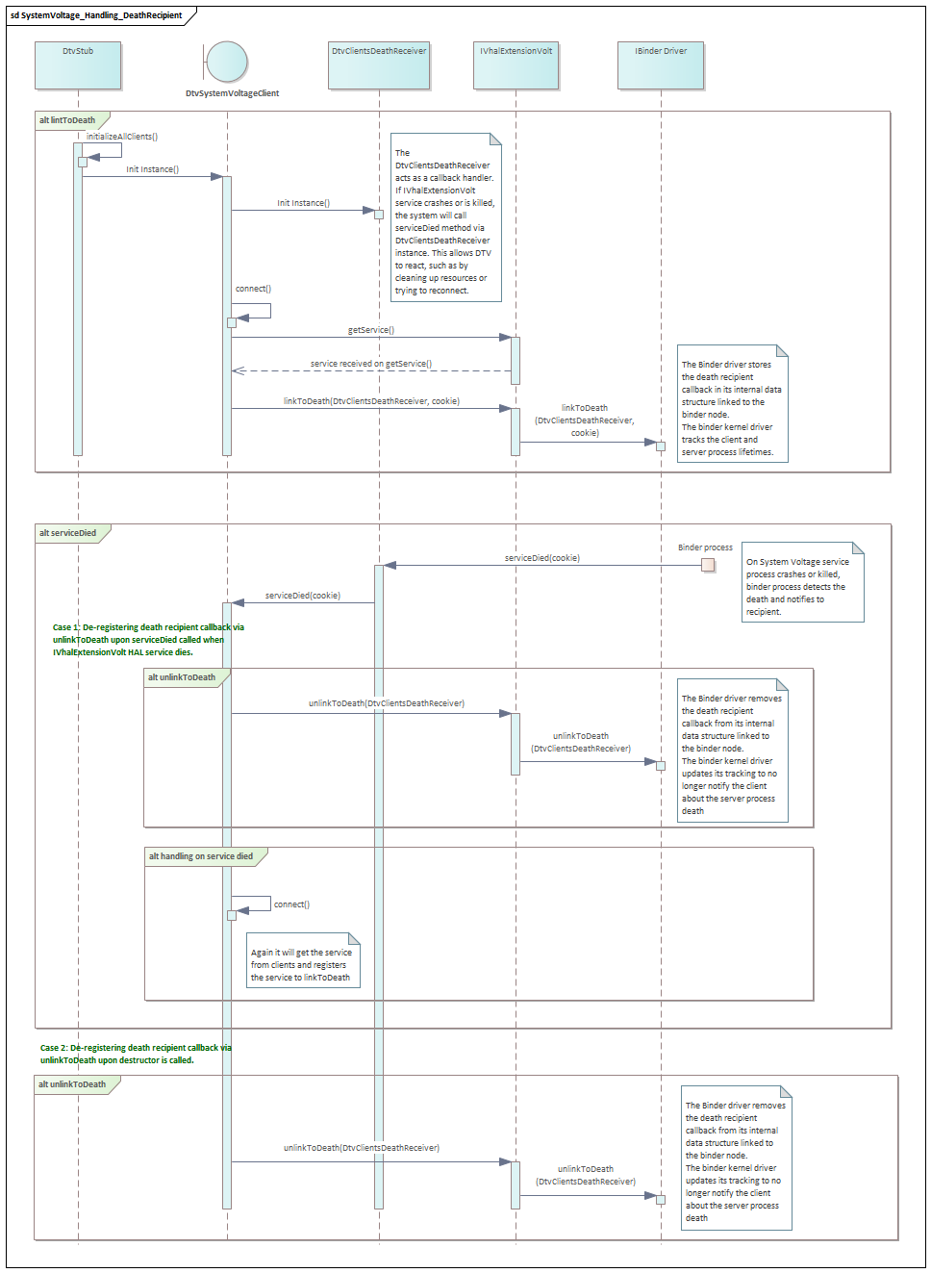

Death Recipient Handling for Thermal Hal client:
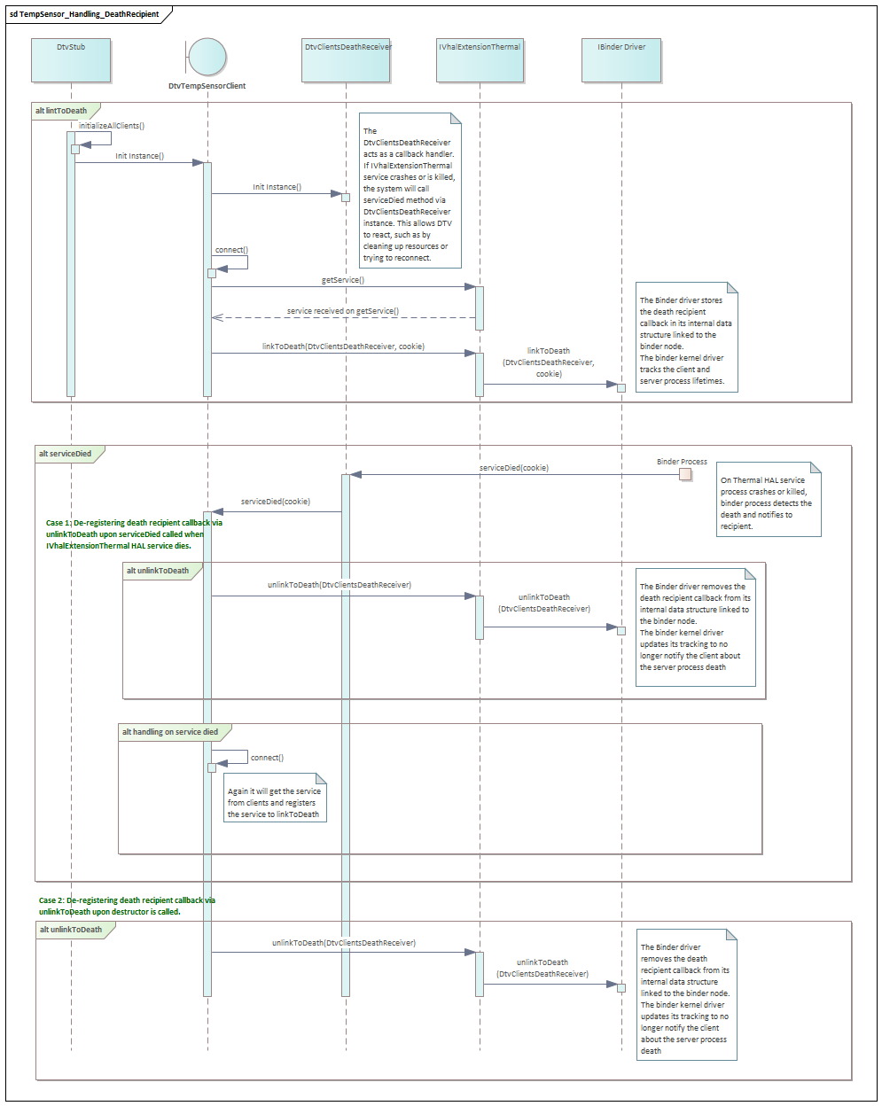

Detailed Design
This section contains details to a level needed that all important architectural decisions are taken and the development can be started. Within this given boundaries, the developer is free to do own decisions.

Static Design on Detail Level

Class interaction diagram
The below diagram depicts the class interaction diagram.

Analyzed Alternatives

Mechanisms and Algorithms

Dynamic Design on Detail Level
This section describes the dynamic interactions on detail level. This chapter can be skipped if the description in 6.3 Dynamic design on high level is detailed enough.

Concurrency / Threading Model
This section describes the threading model for the SW modules. In addition, a distinction is shown which threads are started within the current process space and which processes are started separately (e.g. via fork, spawn), if any.
Thread | Process space | Started by | Description incl. concurrency issues
DTV Hal Main Thread |  | HwServiceManager | This thread is created at service startup
uartTxHandler |  | DTV Hal Main Thread | This thread handles sending requests and processing response from TV Module
uartRxHandker |  | DTV Hal Main Thread | This thread receives data from TV Module via UART port and forms full packet and adds into messageQ
eventObserver |  | DTV Hal Main Thread | This thread serializes all message and timer events. All callbacks out of dtvlib is posted from this thread context

Data Model View
This section describes the used storage mechanism (e.g. SQLite DB, datapool, …) as well as the concrete files incl. path used by the SW modules. It also describes how data integrity is secured and data can be set back to factory defaults.

Storage Mechanism
This section describes the persistence mechanisms used by the subsystem incl. the error handling (e.g. incompatible data found).
SW Module | Used Storage Mechanism

Migration of Data Structures / Error Handling
When a system is started data structures may be incompatible due to a file system corruption (bit flips) or structure change (SW update). How this expected behavior is handled by the storage mechanism is described here.

Set to Delivery State
While production test several amounts of data will be written. At the end of production a “Set to delivery” function is called. This chapter describes how the subsystem, or SW module get the trigger of “set to delivery” and which data will be reset.

Data List
Persistent data that is in ownership of the subsystem is listed here. “Short Description” contains a brief description. “Used persistence mechanism” is a reference to 0. “Max Size” could be a static value or a formula if it is dependent on other values defined in the requirements. The “Max Size” is a prediction at design time and shall be measured after implementation to check the correctness (see chapter 6.60
Critical Computer Resources (CPU, RAM, Flash)). “When read and written” defines if the data is written on every change or e.g. only while shut down, etc. Default value explains which values are written during creation or Set to Delivery state. File System rights are the minimum needed access rights (e.g. for concurrent usage). ” Deletion while SW update” describes the behavior, when a SW Update is executed (e.g. file is deleted during update or not (if not, data needs to be converted by owner at next startup if needed))

Location in flash | Short description | Used persistence mechanism (see 0) | Max Size | When read and written? | Default data | File system rights | Deletion while SW update? [yes/no]

Configuration
DTV HAL should be started based on Module availability/Region based system property, currently there are
no interactions planned with configHub

Critical Computer Resources (CPU, RAM, Flash)
This section describes the prediction of the CPU needs, Flash and RAM of the Subsystem.

SW Modul | CPU  [% of one ARM 9 core) | Flash  (see Data list) | Max RAM  [MB] | GPU Memory  [MB]

Install View
This section describes where the files (executables, libraries, data) of the SW module are stored in the flash file system or at other locations.

File | Directory | Description
vendor.bosch.hardware.dtv@1.0 | Binary Path in Source: out/target/product/aivi2_n_full_us/vendor/lib64/ vendor.bosch.hardware.dtv@1.0.so  Binary Path in Target:  vendor/lib64/vendor.bosch.hardware.dtv@1.0.so  system/lib64/vendor.bosch.hardware.dtv@1.0.so | HIDL library
vendor.bosch.hardware.dtv@1.0-service | Binary Path in Source: out/target/product/aivi2_n_full_us/vendor/bin/hw/ vendor.bosch.hardware.dtv@1.0-service  Binary Path in Target:  vendor/bin/hw/vendor.bosch.hardware.dtv@1.0-service | DTV HAL

Security User and Groups
All needed users and groups to implement the Multi-User-Security-Concept are listed here.
Process | User | Needed groups
vendor.bosch.hardware.dtv@1.0-service | system | system

Testing & Debugging
DTV HAL and framework service is tested using DTV Demo Application.
Traces related to DTV Hal can be checked in logcat by searching for tag dtvhal,dtvlib and log level can be controlled using below command
setprop persist.log.tag.dtvlib DEBUG
setprop persist.log.tag.dtvhal DEBUG

VTS
- VTS (Vendor Test Suite) is a set of test cases and framework designed to test the following components:
- Hardware Abstraction Layer (HAL) modules
- Vendor native libraries (e.g., Vendor NDK, shortly VNDK)
- OS (i.e., Linux kernel)
- VTS covers both functional and non-functional.
- The test cases are divided into modules and grouped together in plans.

VTS Test Cases
- Test cases in VTS test cases go into modules (files)
- A module can contain one or more test cases. All test cases are considered individually for reporting purpose, as long as the right template is used.
- Modules can be run individually.

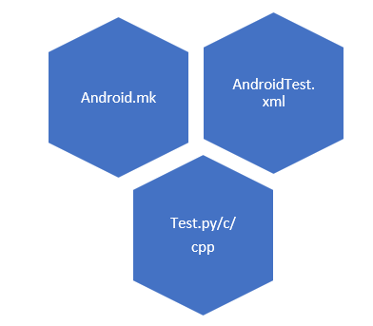
Figure 10

- Each module has its own folder, somewhere within the previously shown structure.
- The code for the test case/s itself might reside in either of Python, C or C++ file.
- Each test case will generally be a function, name prefixed with test/TEST/TEST_F/TEST_P

How to run VTS testcases
- Trade Federation (Tradefed or TF for short) is a continuous test framework designed for running tests on Android devices. For example, Tradefed is used to run the VTS.
- Trade Federation is a Java application which runs on a host computer and communicates to one or more Android devices over ADB.
- VTS test Plan can be run via the commands vts-tradefed and run vts
- Default run vts runs all the available vts testcases under every module, you can provide options to the vts run command, to run a specific module or run a specific test case from a module.

Requirements to other Components
Requirements to other components based on architecture work within this document are listed here.

Component / Generic | Requirement

Source Code Reference

DTV HAL
vendor/bosch/hardware/interfaces/dtv/1.0

DTV Config
vendor/bosch/hardware/interfaces/dtv/dtvconfig

Open Points
- Handling of temp alert from module
- Handling shutdown seqeunce
- Handling of DTC
- Firmware update concept from swupdate team

References and Related Documents
Link | Link | Scope
 | Test Specification | Document to record sensible test cases which are created with the test team.
 | Architecture Roadmap | If available:  RSL Document: https://sites.inside-share2.bosch.com/sites/152810/Documents/0400.Software/04.Work_Products/02.SW_Architecture/F-A14-01_Alliance Android Software Platform Architecture Constraints-v4.7.pdf
 | Requirement Specification
 | DTC interface references | The diag resource file defining the DTC interface:  https://rbcm-ccs2-opengrok.de.bosch.com/source/xref/ccs2_qpr3_a12_int/vendor/alliance/hardware/interfaces/automotive/diagnosis/2.0/default/inc/DiagDTV.h

Contacts
List of persons who maintain this module as well as persons who should be asked for acceptance when the interface or the behavior of the module shall be changed (e.g. if a message format shall be changed)

No | Name | Comment

Amendments

Revision History
Date | Version | Status | Review-Minutes | Amendments | Author
22/06/2023 | 0.1 | UPDATE |  | Add “Sync handler - Blocking call” item | Nguyen Quoc Dat  (MS/EMC23-XC)
03/11/2023 | 1.0 | Release |  | Review corrections | Chaitra Bharadwaj
01/04/2024 | 1.1 | UPDATE |  | Add “Software update” item | Nguyen Quoc Dat  (MS/EMC21-XC)
17/04/2024 | 1.1 | UPDATE |  | Update the Software update sequence diagrams. | Nguyen Quoc Dat  (MS/EMC21-XC)
02/05/2024 | 1.1 | UPDATE |  | Add “Diagnostic Trouble Code (DTC) handling” item | Nguyen Quoc Dat  (MS/EMC21-XC)
01/07/2024 | 1.1 | UPDATE |  | Add “DTV Critical Error” item | Nguyen Quoc Dat  (MS/EMC21-XC)
18/07/2024 | 1.2 | UPDATE |  | Add “Low Voltage Handling” item and “Antenna Monitoring” item | Ajay J Thampy (MS/ECR6-XC)
05/02/2025 | 1.3 | UPDATE |  | Add “Software Update Validation” item.  Update the Low Voltage Handling content to reflect the change in the range for powering OFF/ON the TV module and Antenna. | Nguyen Quoc Dat  (MS/EMC21-XC)
30/05/2025 | 1.4 | UPDATE |  | Update the “Software Update Validation” sequence for testing firmware and add the “SW Update Mode Identification” figure in page 15 and 16. | Nguyen Quoc Dat  (MS/EMC21-XC)
09/06/2025 | 1.5 | UPDATE |  | Add “Death Recipients Handling” for DTV clients and sequences for DTC, System voltage and Thermal Hal clients in page 32, 33, 34 and 35. | Ganesh Raju Nandi (MS/ECR-XC)
26/09/2025 | 1.6 | UPDATE |  | Update the “Software Update” sequence and state machine diagrams in page 17, 18, 19 and 20. | Nguyen Quoc Dat (MS/EMC21-XC)
16/07/2026 | 1.7 | UPDATE |  | Add the CarPowerManager state machine and update SHUTDOWN_CANCELLED handling for the “6.3.5 Suspend to Disk” item | Nguyen Quoc Dat (MS/EMC32-XC)

